=>1)Connecting to Metamask with Vanilla JS

Create a New Directory for the Tutorial

mkdir web3js-metamask-tutorial
cd web3js-metamask-tutorial

Use MetaMask as the Web3.js Provider

Create a new file called index.html in your project directory and add the following HTML to it:

<!DOCTYPE html>
<html lang="en">
<head>
<meta charset="UTF-8" />
<meta name="viewport" content="width=device-width, initial-scale=1.0" />
<title>Web3.js MetaMask Tutorial</title>
<!-- import Web3.js -->
<script src="https://cdn.jsdelivr.net/npm/web3@latest/dist/web3.min.js"></script>
</head>
<body>
<!-- placeholders -->
<div id="provider"></div>
<div id="chainId"></div>
<div id="latestBlock"></div>
<div id="warn" style="color: red"></div>
<script type="module">
// ensure that there is an injected the Ethereum provider
if (window.ethereum) {
// use the injected Ethereum provider to initialize Web3.js
const web3 = new Web3(window.ethereum);

// check if Ethereum provider comes from MetaMask
if (window.ethereum.isMetaMask) {
document.getElementById('provider').innerText =
'Connected to Ethereum with MetaMask.';
} else {
document.getElementById('provider').innerText =
'Non-MetaMask Ethereum provider detected.';
}

// get chain ID and populate placeholder
document.getElementById(
'chainId',
).innerText = `Chain ID: ${await web3.eth.getChainId()}`;
// get latest block and populate placeholder
document.getElementById(
'latestBlock',
).innerText = `Latest Block: ${await web3.eth.getBlockNumber()}`;

// subscribe to new blocks and update UI when a new block is created
const blockSubscription = await web3.eth.subscribe('newBlockHeaders');
blockSubscription.on('data', block => {
document.getElementById(
'latestBlock',
).innerText = `Latest Block: ${block.number}`;
});
} else {
// no Ethereum provider - instruct user to install MetaMask
document.getElementById('warn').innerHTML =
"Please <a href='https://metamask.io/download/'>install MetaMask</a>.";
}
</script>
</body>
</html>

=>open command prompt and run
npx watch-http-server .

you will see the below output

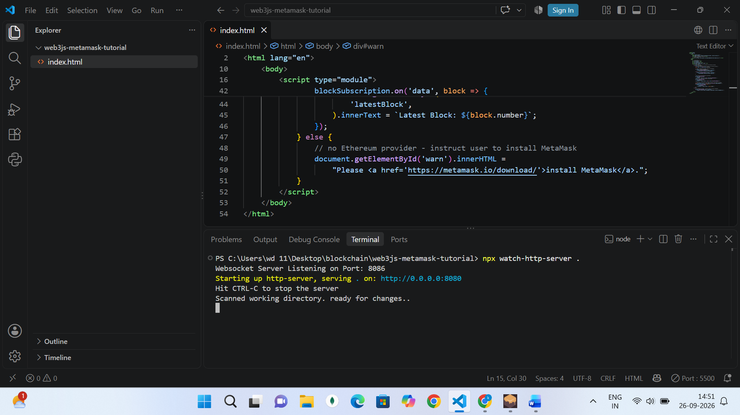

=>2)Create one more file in the same folder called index2.html and paste the below code
(Request Access to the MetaMask Accounts)

<!DOCTYPE html>
<html lang="en">
<head>
<meta charset="UTF-8" />
<meta name="viewport" content="width=device-width, initial-scale=1.0" />
<title>Web3.js MetaMask Tutorial</title>
<!-- import Web3.js -->
<script src="https://cdn.jsdelivr.net/npm/web3@latest/dist/web3.min.js"></script>
</head>
<body>
<!-- placeholders -->
<div id="provider"></div>
<div id="chainId"></div>
<div id="latestBlock"></div>
<div id="connectedAccount"></div>
<div id="warn" style="color: red"></div>

<div>
<button id="requestAccounts">Request MetaMask Accounts</button>
</div>
<script type="module">
// ensure that there is an injected the Ethereum provider
if (window.ethereum) {
// use the injected Ethereum provider to initialize Web3.js
const web3 = new Web3(window.ethereum);

// check if Ethereum provider comes from MetaMask
if (window.ethereum.isMetaMask) {
document.getElementById('provider').innerText =
'Connected to Ethereum with MetaMask.';
} else {
document.getElementById('provider').innerText =
'Non-MetaMask Ethereum provider detected.';
}

// get chain ID and populate placeholder
document.getElementById(
'chainId',
).innerText = `Chain ID: ${await web3.eth.getChainId()}`;
// get latest block and populate placeholder
document.getElementById(
'latestBlock',
).innerText = `Latest Block: ${await web3.eth.getBlockNumber()}`;

// subscribe to new blocks and update UI when a new block is created
const blockSubscription = await web3.eth.subscribe('newBlockHeaders');
blockSubscription.on('data', block => {
document.getElementById(
'latestBlock',
).innerText = `Latest Block: ${block.number}`;
});

// click event for "Request MetaMask Accounts" button
document.getElementById('requestAccounts').addEventListener('click', async () => {
// request accounts from MetaMask
await window.ethereum.request({ method: 'eth_requestAccounts' });
document.getElementById('requestAccounts').remove();

// get list of accounts
const accounts = await web3.eth.getAccounts();
// get the first account and populate placeholder
document.getElementById(
'connectedAccount',
).innerText = `Account: ${accounts[0]}`;
});
} else {
// no Ethereum provider - instruct user to install MetaMask
document.getElementById('warn').innerHTML =
"Please <a href='https://metamask.io/download/'>install MetaMask</a>.";
document.getElementById('requestAccounts').disabled = true;
}
</script>
</body>
</html>

=>right click and open live server and you will see this

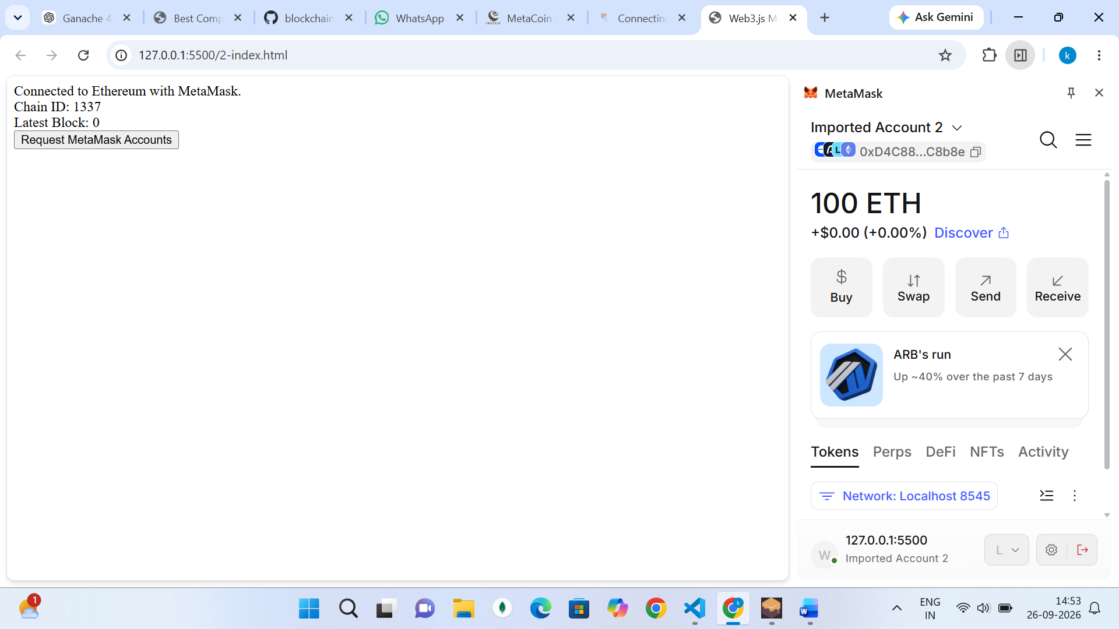

=>click on request metamask accounts and you can see the account that is current linked to the metamask wallet display on the screen

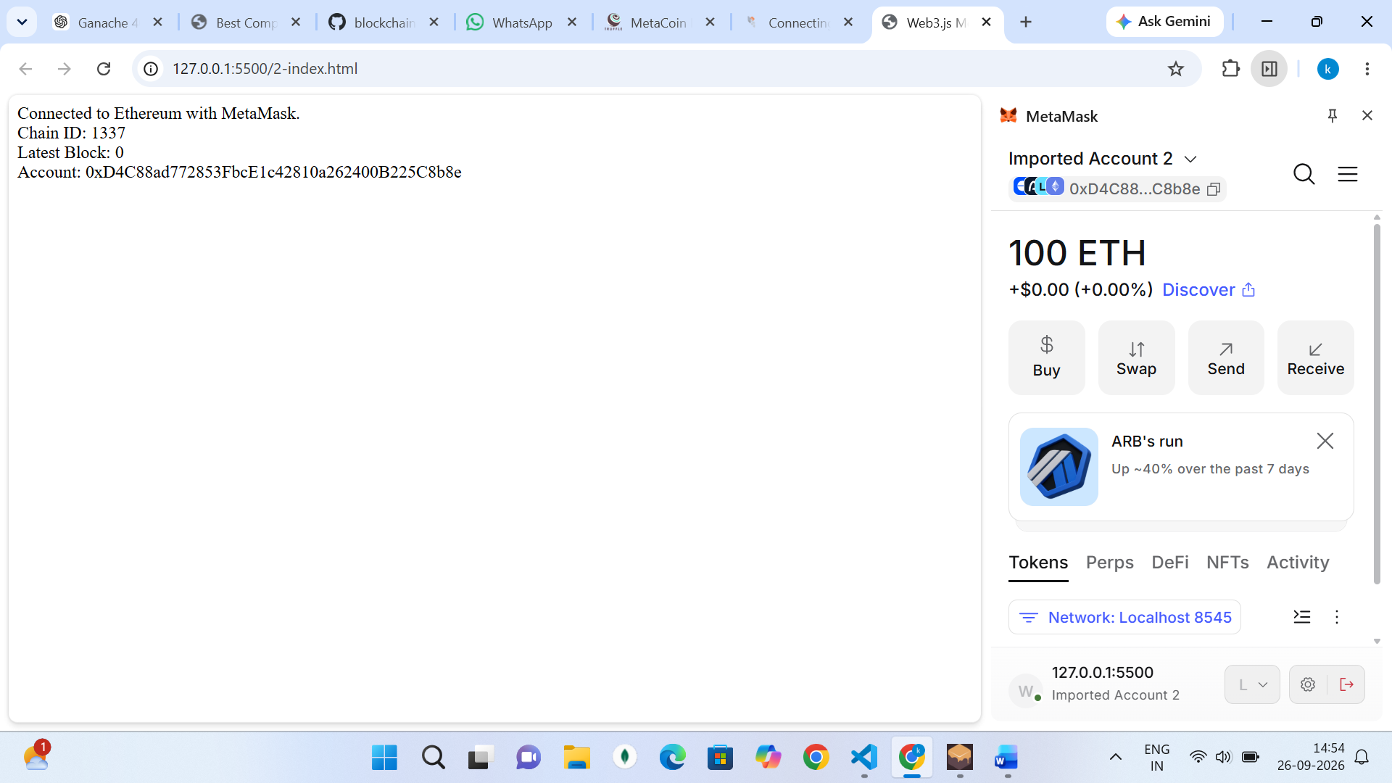
=>3)create a new file called 3-index.html in the same folder and paste the below code
(Sign a Message with a MetaMask Account)

<!DOCTYPE html>
<html lang="en">
<head>
<meta charset="UTF-8" />
<meta name="viewport" content="width=device-width, initial-scale=1.0" />
<title>Web3.js MetaMask Tutorial</title>
<!-- import Web3.js -->
<script src="https://cdn.jsdelivr.net/npm/web3@latest/dist/web3.min.js"></script>
</head>
<body>
<!-- placeholders -->
<div id="provider"></div>
<div id="chainId"></div>
<div id="latestBlock"></div>
<div id="connectedAccount"></div>
<div id="warn" style="color: red"></div>

<div>
<button id="requestAccounts">Request MetaMask Accounts</button>
</div>

<div>
<input id="messageToSign" placeholder="Message to Sign" disabled />
<button id="signMessage" disabled>Sign Message</button>
<div id="signingResult"></div>
</div>
<script type="module">
// ensure that there is an injected the Ethereum provider
if (window.ethereum) {
// use the injected Ethereum provider to initialize Web3.js
const web3 = new Web3(window.ethereum);

// check if Ethereum provider comes from MetaMask
if (window.ethereum.isMetaMask) {
document.getElementById('provider').innerText =
'Connected to Ethereum with MetaMask.';
} else {
document.getElementById('provider').innerText =
'Non-MetaMask Ethereum provider detected.';
}

// get chain ID and populate placeholder
document.getElementById(
'chainId',
).innerText = `Chain ID: ${await web3.eth.getChainId()}`;
// get latest block and populate placeholder
document.getElementById(
'latestBlock',
).innerText = `Latest Block: ${await web3.eth.getBlockNumber()}`;

// subscribe to new blocks and update UI when a new block is created
const blockSubscription = await web3.eth.subscribe('newBlockHeaders');
blockSubscription.on('data', block => {
document.getElementById(
'latestBlock',
).innerText = `Latest Block: ${block.number}`;
});

// click event for "Request MetaMask Accounts" button
document.getElementById('requestAccounts').addEventListener('click', async () => {
// request accounts from MetaMask
await window.ethereum.request({ method: 'eth_requestAccounts' });
document.getElementById('requestAccounts').remove();

// get list of accounts
const accounts = await web3.eth.getAccounts();
// get the first account and populate placeholder
document.getElementById(
'connectedAccount',
).innerText = `Account: ${accounts[0]}`;

// enable signing input
const messageToSign = document.getElementById('messageToSign');
const sign = document.getElementById('signMessage');
messageToSign.disabled = false;
sign.disabled = false;

// click event for "Sign Message" button
sign.addEventListener('click', async () => {
// sign message with first MetaMask account
const signature = await web3.eth.personal.sign(
messageToSign.value,
accounts[0],
'',
);

// update placeholder with signed message
document.getElementById(
'signingResult',
).innerText = `Signed Message: ${signature}`;
});
});
} else {
// no Ethereum provider - instruct user to install MetaMask
document.getElementById('warn').innerHTML =
"Please <a href='https://metamask.io/download/'>install MetaMask</a>.";
document.getElementById('requestAccounts').disabled = true;
}
</script>
</body>
</html>
=>right click and open in live server and you will see this

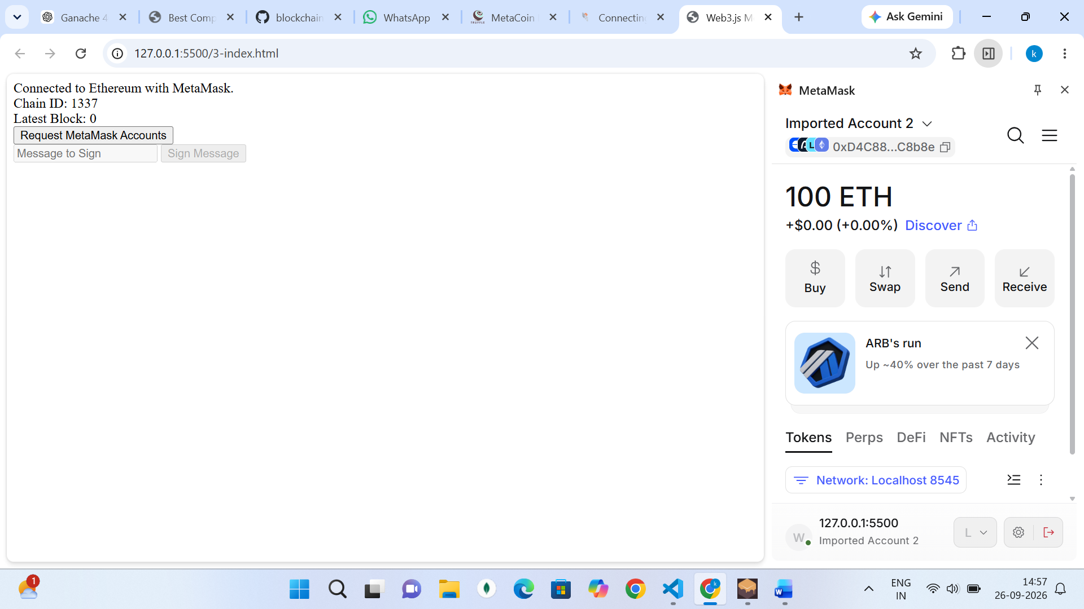

=>click on request metamast accounts and then give a message in the message to sign input box then u will be asked permission confirm it

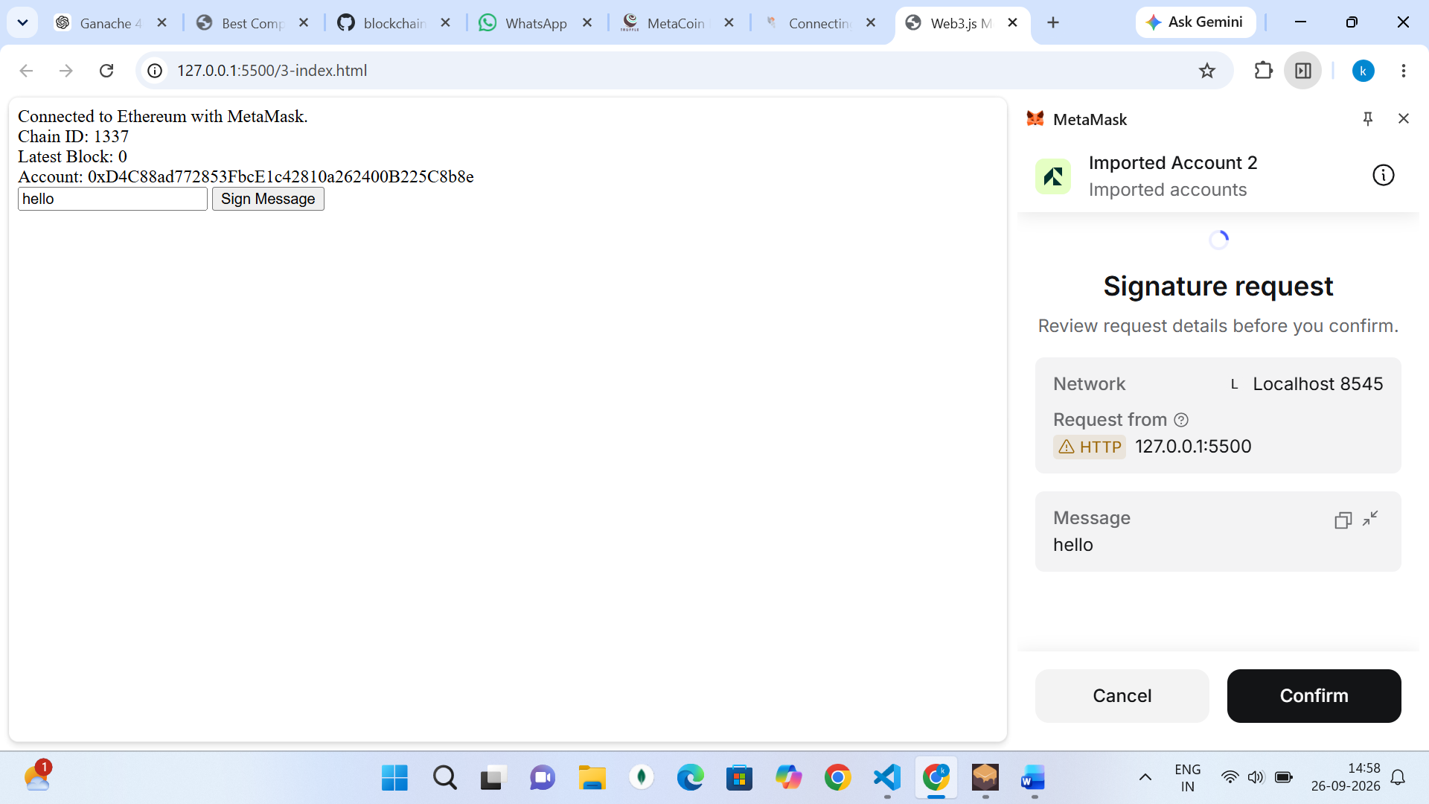

=>MetaMask uses the account's private key to digitally sign a message. The long hexadecimal value is the signature, which can later be used to verify that the account owner signed that message.

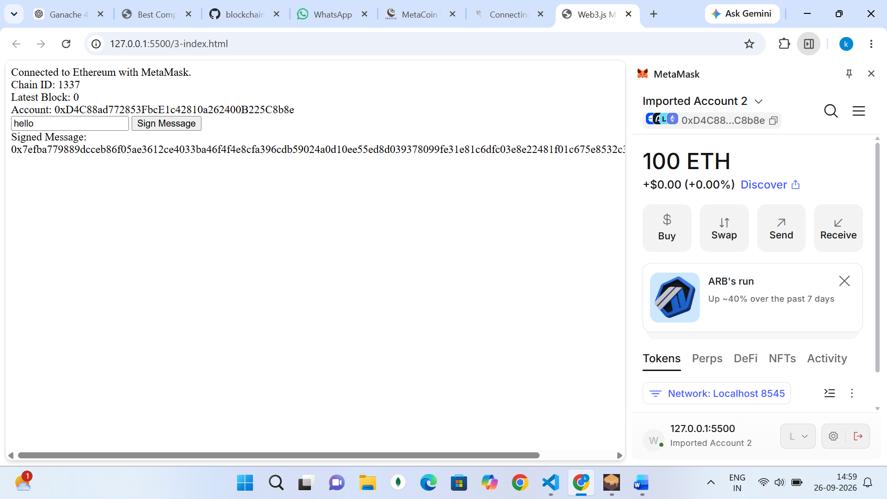

=>4)create a new file called 4-index.html and copy paste the below code
(Verify the Account Used to Sign a Message)

<!DOCTYPE html>
<html lang="en">
<head>
<meta charset="UTF-8" />
<meta name="viewport" content="width=device-width, initial-scale=1.0" />
<title>Web3.js MetaMask Tutorial</title>
<!-- import Web3.js -->
<script src="https://cdn.jsdelivr.net/npm/web3@latest/dist/web3.min.js"></script>
</head>
<body>
<!-- placeholders -->
<div id="provider"></div>
<div id="chainId"></div>
<div id="latestBlock"></div>
<div id="connectedAccount"></div>
<div id="warn" style="color: red"></div>

<div>
<button id="requestAccounts">Request MetaMask Accounts</button>
</div>

<div>
<input id="messageToSign" placeholder="Message to Sign" disabled />
<button id="signMessage" disabled>Sign Message</button>
<div id="signingResult"></div>
</div>

<div>
<input id="originalMessage" placeholder="Original Message" disabled />
<input id="signedMessage" placeholder="Signed Message" disabled />
<button id="recoverAccount" disabled>Recover Account</button>
<div id="signingAccount"></div>
</div>
<script type="module">
// ensure that there is an injected the Ethereum provider
if (window.ethereum) {
// use the injected Ethereum provider to initialize Web3.js
const web3 = new Web3(window.ethereum);

// check if Ethereum provider comes from MetaMask
if (window.ethereum.isMetaMask) {
document.getElementById('provider').innerText =
'Connected to Ethereum with MetaMask.';
} else {
document.getElementById('provider').innerText =
'Non-MetaMask Ethereum provider detected.';
}

// get chain ID and populate placeholder
document.getElementById(
'chainId',
).innerText = `Chain ID: ${await web3.eth.getChainId()}`;
// get latest block and populate placeholder
document.getElementById(
'latestBlock',
).innerText = `Latest Block: ${await web3.eth.getBlockNumber()}`;

// subscribe to new blocks and update UI when a new block is created
const blockSubscription = await web3.eth.subscribe('newBlockHeaders');
blockSubscription.on('data', block => {
document.getElementById(
'latestBlock',
).innerText = `Latest Block: ${block.number}`;
});

// click event for "Request MetaMask Accounts" button
document.getElementById('requestAccounts').addEventListener('click', async () => {
// request accounts from MetaMask
await window.ethereum.request({ method: 'eth_requestAccounts' });
document.getElementById('requestAccounts').remove();

// get list of accounts
const accounts = await web3.eth.getAccounts();
// get the first account and populate placeholder
document.getElementById(
'connectedAccount',
).innerText = `Account: ${accounts[0]}`;

// enable signing input
const messageToSign = document.getElementById('messageToSign');
const sign = document.getElementById('signMessage');
messageToSign.disabled = false;
sign.disabled = false;

// click event for "Sign Message" button
sign.addEventListener('click', async () => {
// sign message with first MetaMask account
const signature = await web3.eth.personal.sign(
messageToSign.value,
accounts[0],
'',
);

// update placeholder with signed message
document.getElementById(
'signingResult',
).innerText = `Signed Message: ${signature}`;
});

// enable signature verification input
const originalMessage = document.getElementById('originalMessage');
const signedMessaged = document.getElementById('signedMessage');
const recoverAccount = document.getElementById('recoverAccount');
originalMessage.disabled = false;
signedMessaged.disabled = false;
recoverAccount.disabled = false;

// click event for "Recover Account" button
recoverAccount.addEventListener('click', async () => {
// recover account from signature
const account = await web3.eth.personal.ecRecover(
originalMessage.value,
signedMessaged.value,
);

// update placeholder with recovered signature account
document.getElementById(
'signingAccount',
).innerText = `Signing Account: ${account}`;
});
});
} else {
// no Ethereum provider - instruct user to install MetaMask
document.getElementById('warn').innerHTML =
"Please <a href='https://metamask.io/download/'>install MetaMask</a>.";
document.getElementById('requestAccounts').disabled = true;
}
</script>
</body>
</html>

=>right click and open with live server and u will see this
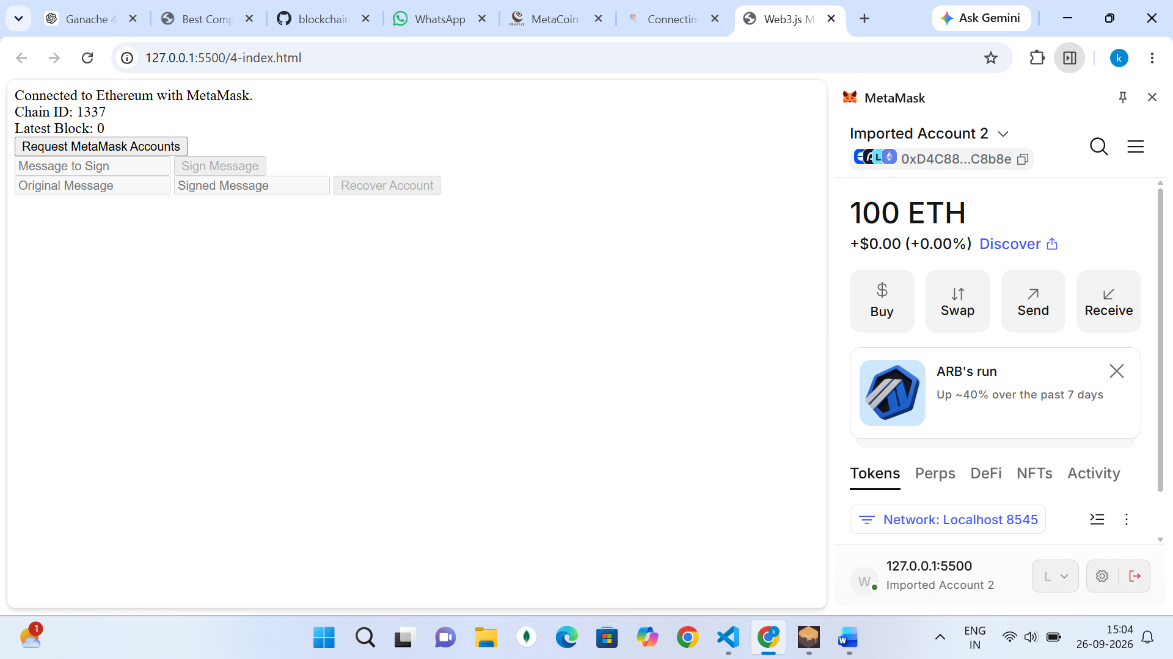

Click on request metamask accounts then fill the details like below then you can see the account that was used to sign the message

